ARTICLE TITLE
Times New Roman 12pt bold
(Two blank line)
Jung-Heui Oh¹, Li Jun^{2*}
Times New Roman 12pt bold
¹Department of XXX, Department of Statistics, Chung Ang University, Korea
²Faculty of YYY, Department of Mathematics, Anhui University, China
Times New Roman 12pt bold
(One blank line)
*Correspondence Author : E-mail: zzz@xxx.ac.in
Times New Roman 12pt bold
(One blank line)
Abstract
This is a template for International Journal of Applied Engineering & Technology. The abstract is required to be written in English (150-250 words in ONE paragraph) with brief descriptions of purpose, methods, results, and conclusions. Please be sure to emphasize the original and important aspects of your research. It is the responsibility of the authors to strictly adhere to this template for the smooth review and publication process of the manuscript. Margins: top and bottom 25mm; left and right 20mm Times New Roman 12pt Italic
(One blank line)
Keywords: evergreen; Green Asia strategy; novel carbon resource sciences Times New Roman 12pt Italic
(One blank line)
1. INTRODUCTION Times New Roman 12pt Bold
Body text: Times New Roman 12pt, 6pt paragraph, Single Column
Use the following table format in the manuscript. Note that all the tables and figures should be cited in the paragraph as Table 1 and Fig. 1 where appropriate.
(One blank line)
Table 1 Hospitals’ Prediction Accuracy Times New Roman 12pt, 12pt pa
Type of Narcotic Drugs | MAD | TS | RMSE | MAPE
Codeine 30mg/Acetam.300mg (Tylenol #3) T. | 153,757 | -5.0 | 177,314 | 47%
Tramadol 50mg Capsule | 123,055 | -6.0 | 137,232 | 42%
Morphine Sulphate 10mg/1ml Injection | 32,370 | -6.0 | 40,251 | 46%
Clonazepam 0.5mg Tablet | 24,736 | -1.6 | 30,009 | 47%
Lorazepam 1mg Tablet | 20,730 | -4.9 | 24,710 | 51%

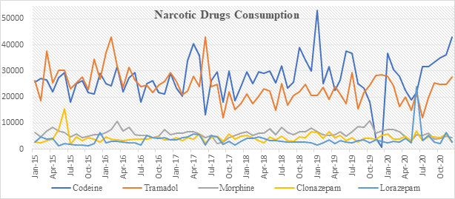
Fig. 1: Use minimum number of figures required. You cannot use same indications for different tables or figures. Information given in captions should not be repeated in the text. 12point; Single paragraph
(One blank line)
All figures, whether photographs, graphs, or diagrams, should be cited in the text and numbered sequentially with Arabic numerals.
(One blank line)
References
All sources cited in the text must appear in the reference list and all items in the reference list must be cited in the text. Reference must be arranged in alphabetic order. A brief guideline for referencing of the most common types of documents is provided here:
Journal article with a Single author
Last Name, First Name. (Year of publication). Article Title. Journal Name, Volume No (Issue No), Page No, DOI
Example
Akpan, E. (2003). Early marriage in Eastern Nigeria and the Health consequences of vesicovaginal fistulae (VVF) among young mothers. Gender and Development, 11(2), 70-76

Journal article with Multiple author
Last Name, First Name. & Last Name, First Name. (Year of publication). Article Title. Journal Name, Volume No (Issue No), Page No. DOI
Example
Alamri, H. R., Alanazi, A. R., & Alrashedi, S. M. (2021). Anxiety in Writing Skills: the Voices of EFL University Learners. International Journal of English Language Teaching, 9(6), 33-51.

Book
Author name, (Year)"Title of chapter in the book, "Title of the Published Book, (xth ed. if possible), Abbrev. of Publisher, pp. xxx–xxx.
Examples
Tom B, Jack E, R. Voss, (2013) "The Current Situation of Education," in Current Situation and Development of Contemporary Education, 1st ed, HRPUB, pp. 1-200.
Fuare, R., Grabowski, R.,& Grosskopf,S.(1985). The measurement of efficiency of production. Boston: Kluwer Academic Publishers

Chapter in an edited book
Example
Mettam, G.R., Adams, L.B., (1999). How to prepare an electronic version of your article, in: Jones, B.S., Smith, R.Z. (Eds.), Introduction to the Electronic Age. E-Publishing Inc., New York, pp. 281-304.

Conference Proceedings
Author. Year Published. Title. Proc. Conference Name, Edition, Conference Location, Year of Conference, Volume, Pages, Place Published, Publisher
Example
Mohan Jain S. 2013. Mutation-assisted breeding for improving ornamental plants. Proc. XXII International Eucarpia Symposium, Section Ornamentals, Breeding for Beauty, Thuringia, 2013, 714:85-98. Thuringia: Tuorix Press
f) Website
Author/Organization. Year. Title. URL
Example
Biostimulant Coalition. 2013. What are the biostimulants? www.biostimulantcoalition.org

